Checkpoint 1

# Haptic Lathe Simulator

### Description

We are building a two‑DOF haptic training device that mimics the hand‑feel of operating a manual lathe. The user turns two perpendicular, directly‑driven handwheels (X cross‑slide and Z carriage). A virtual lathe environment renders stock, tool, drawings/tolerances, and live readouts of X/Z positions. The device computes and reflects realistic cutting forces/torques based on spindle speed, feed, and depth of cut—allowing trainees to practice common machining operations (e.g., facing, turning to diameter, boring) in a low‑risk setting while building correct muscle memory. The architecture extends naturally to a milling mode (stretch goal).

### Related Literature

<https://ieeexplore.ieee.org/document/8590115> ]

Mill simulator

<https://link.springer.com/article/10.1007/s10055-023-00816-w>

<https://www.sciencedirect.com/science/article/pii/S2212827116312665>

<https://ieeexplore.ieee.org/abstract/document/5406525>

[1]X. He and Y. Chen, "A Haptic Virtual Turning Operation System," 2006 International Conference on Mechatronics and Automation, Luoyang, China, 2006, pp. 435-440, doi: 10.1109/ICMA.2006.257573.

[Online]. Available: <https://ieeexplore.ieee.org/document/4026122>

**A Haptic Virtual Turning Operation System**  
The paper presents the **Haptic Virtual Turning Operation System (HVTOS)**, a prototype that simulates lathe machining with realistic haptic, visual, and audio feedback for training and modeling applications. Using a PHANToM® haptic device, users can perform virtual cutting, browsing, and grinding operations on NURBS-modeled workpieces, experiencing force feedback that varies with parameters such as cutting depth, material hardness, surface friction, and spindle speed. The system employs NURBS deformation and trimming algorithms to efficiently update workpiece geometry and simulate polishing effects in real time, while spring-damper-based force models replicate the dynamics of tool–workpiece interaction. Developed in C++ and OpenGL with OpenHaptics™, HVTOS records tool positions and forces for analysis and demonstrates the potential of multi-sensory virtual machining as a low-cost, intuitive training tool for understanding machining mechanics and improving operator skills.

<https://sites.lafayette.edu/turnin-and-burnin/>

### Why we are Switching to a New Idea

Before landing on this concept, our group initially explored developing a haptic underwater welding simulator. While the idea was interesting, we struggled to design a convincing and achievable system within our time and budget constraints. Existing haptic welding simulators already perform similar tasks, and we found it difficult to identify a way to meaningfully improve or offer something truly novel to that concept. Furthermore, none of us have direct experience with welding, especially underwater welding,making it hard to validate or tune the realism of our design. In contrast, all of us have hands-on experience machining, which makes the haptic machining simulator both more feasible and more relevant. It will also enable us to conduct a more effective usability study since many of our classmates have machining experience.

### Checkpoints & deliverables

**Checkpoint 1 — System requirements & concept freeze (Nov 4)**

* Description of Device
* Literature review
* Establish all system requirements
* Initial sketch of the haptic device which include mechanism layout, motor mounts, handles, UI
* Force/Torque Calculations
* Motor selection
* Additional Component Selection
* Electronics selection
* BOM

**Checkpoint 2 — Detailed Mechanical design, parts ordered, and Initial UI (Nov 11)**

* UI wireframe; simple stock/tool visualization running
* CAD for Motor Mount and handles
* Force Feedback Calculations
* Ordered Materials

**Checkpoint 3 — Integration & basic haptics (Nov 18)**

* Manufacture device
* UI linked to motors, live position handling
* 1 task (turning or boring) with scoring
* Single‑axis torque rendering demo (constant “cut” depth)

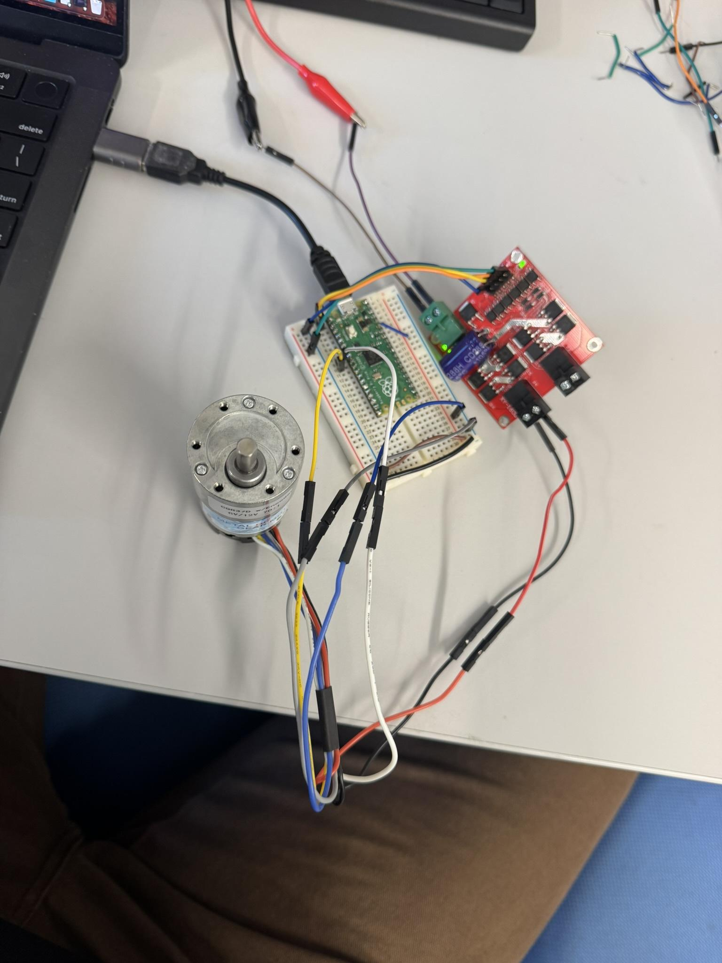

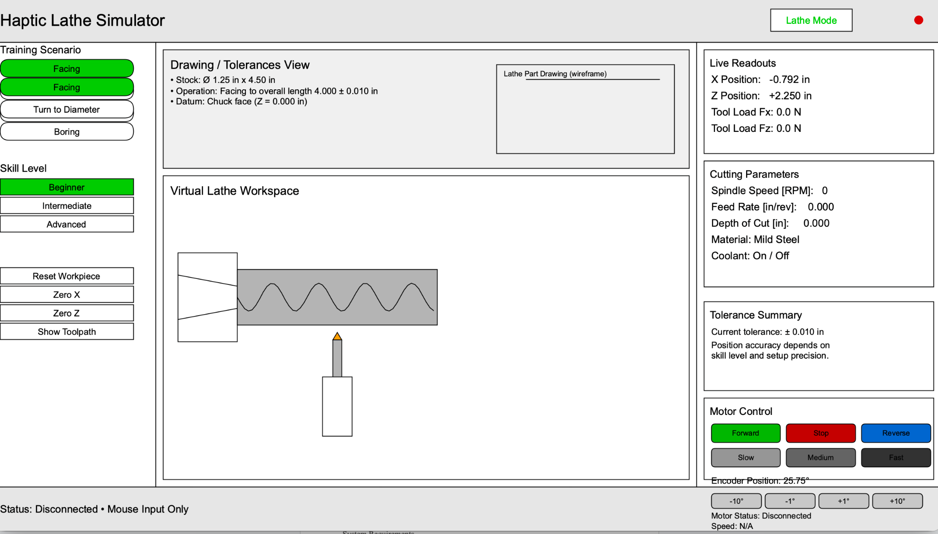

Motor is working and GUI MVP is done. Working on integrating GUI and hardware.

**Checkpoint 4 — MVP demo (Nov 25)**

* Two tasks (turning & boring) fully guided with scoring
* Two-axis torque rendering
* Design Pilot study

**Checkpoint 5 — Refinement and User Pilot Study (Dec 2)**

* Refinement of system
* Complete Pilot Study

### System Requirements

* Motor should be able to provide **~1.2Nm** continuously
  + Mini Late wheel: ~90mm OD

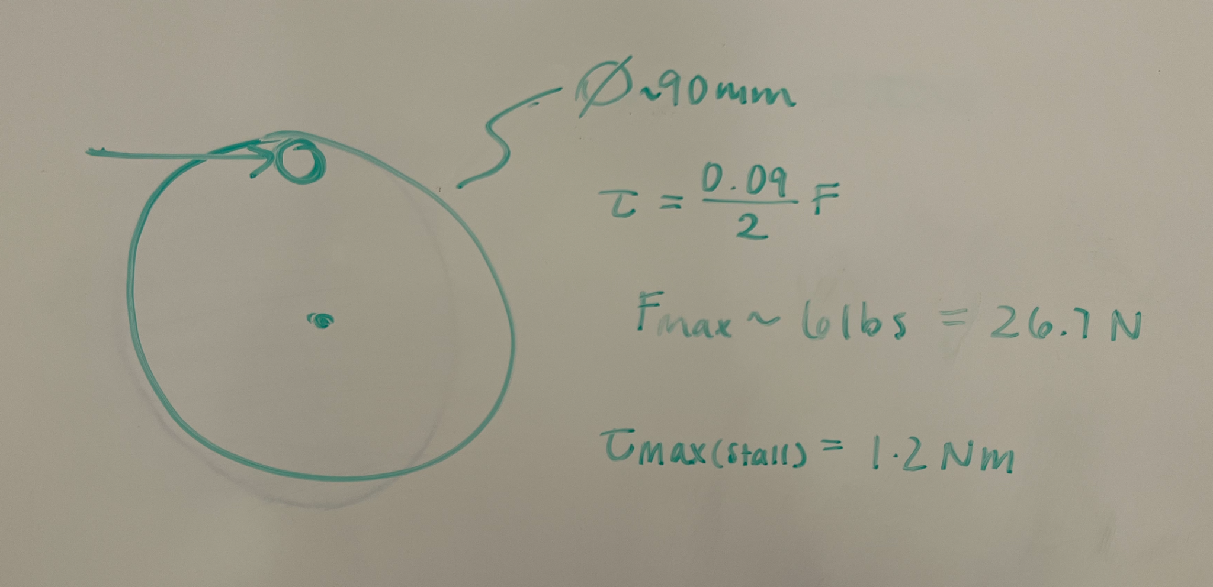

Motor selection: 3.1Nm stall torque 120rpm

### Initial CAD/Sketches

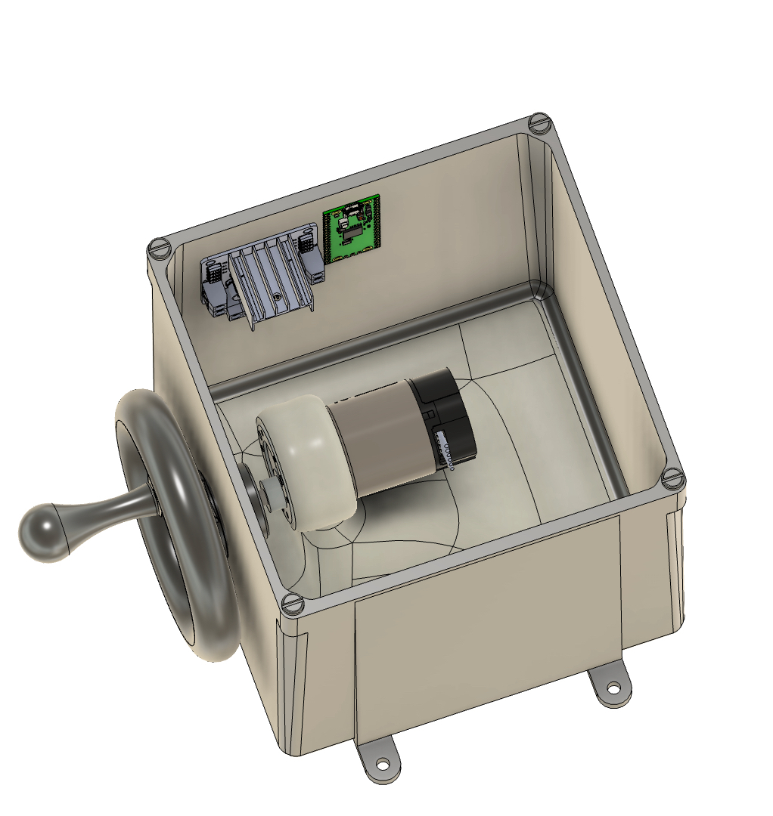

### Bill Of Materials

| Item | Quantity | Price/Item | Total Cost |
| --- | --- | --- | --- |
| [Raspberry Pi Pico](https://www.digikey.com/en/products/detail/raspberry-pi/SC0915/13684020?gclsrc=aw.ds&gad_source=1&gad_campaignid=20243136172&gbraid=0AAAAADrbLlif_aM18D0WIsD3s6SQEYGU0&gclid=CjwKCAiAzrbIBhA3EiwAUBaUdRmsF5EcLQKw4tsK1Ak1hprX4-Jj5EuZ-PS-C71enuHa_nxpypXg8RoCeesQAvD_BwE) | 1 | $4 | $4 |
| [Shaft Coupler](https://www.amazon.com/Cionyce-Coupling-Support-Hardness-Connector/dp/B0B63PVPSX?crid=1LCIXSRGA1A0I&dib=eyJ2IjoiMSJ9.d5JalNhmgl0WD7_x48eWM3Q_GL2ywUs2iZWlGRmr2pequ5UjsiVA2SREbLMJaa3B_NLOwLgW3xE8a-PDc7rJMM1FoQHkbE4DeJaQAlc4tnjrBinxD8ta0NVVxeeTNoL4DVBG2JOVW0FZJdRrNxJ0FwPxEEdcxbX5mI63zDBaOK1OObdMiYLvFNIVUrbbd3K236QQt5Ifg5XMDfrMNjOLIN9RqjEwME3kZaTBRqOAvZk.3ePxQM_Y1rMQguzjVfG-PMu3lTedd_4RoYt66f9LVXk&dib_tag=se&keywords=shaft%2Bcoupler%2Bflange%2B6mm&qid=1762289196&sprefix=shaft%2Bcoupler%2Bflange%2B6mm%2Caps%2C160&sr=8-4&th=1) | 1 | 4.5 | 4.5 |
| [Motor](https://www.amazon.com/CQRobot-Ocean-6V-3W-20RPM-40-oz-12V-6W-40RPM-70/dp/B08ZK8RWK4?crid=3GPVO4IQZOQ73&dib=eyJ2IjoiMSJ9.X-mc67OQp3IUtg3NrTTFXUf51vWBB0LRHjMpuT_8ZToCyetVkOCyNhEUgUKeaxqDgESI_TuFipkRzFrTjm4TR3HG4xFlaRQLSXryuCJdqWMkjwuchS02yYFO8zd8M5qXaUi3EFqqYwacPlGBUURWPOS88zwfdkK9EStQMWJCa0KDQH3am9hOfQpK5a024nUGbjlLyS8lNy_s4CgnL42RexuDSLBvNAD677tcRORpf5mk5Ed1JCml0XJxqNRAqB93aJW0A494c6NBcWxXXA4oSU9X8KLKrbZW6VRMgrAX9zQ.w90hR2OUHzSn192SNStcOd8QJC7v7S3hsdIOVr_CqSQ&dib_tag=se&keywords=dc%2Bmotors%2Bwith%2Bencoders&qid=1762133625&sprefix=dc%2Bmotors%2B%2Caps%2C207&sr=8-10&th=1) (90:1 model) | 1 | 34 | 34 |
| [~~Belt~~](https://www.amazon.com/Suiwotin-Timing-Rubber-Geared-130XL037/dp/B0BFH18GHH?crid=PT0B9HUBEJ2C&dib=eyJ2IjoiMSJ9.aTVuVQI2kOAbsvwlK4_7EYxMF00qzFML7JCu1InivtQ_bhTsyNSCmduXsxfGSrZneImWm7iUmij6rT2-DkTngMduvbhqwpR66WCpBc_d5SwrUDJDp7M3c9tuO6tRS6xI02S96kueNoGYwZt--7SZvyikT6bL6iaX70Q73BuRr28-QFH7gfDsU3rlS0ptfyeS511rPBLylc_eTVVsDZcmQAWTh2sUvRNE2CiqqcV-yg0.d6P9UIuFZA8TSfJ5tEvRWu0fo-63eTf-ccWg-umrsGM&dib_tag=se&keywords=timing%2Bbelt%2Bmm&qid=1762190752&sprefix=timing%2Bbelt%2Bmm%2Caps%2C125&sr=8-8&th=1) | ~~1~~ | ~~5.18~~ | ~~5.18~~ |
| 3DP housing |  |  |  |
| 3DP gears |  |  |  |
| [6mm ID bushing](https://www.amazon.com/uxcell-Bearings-Thickness-Sintered-Self-Lubricating/dp/B095N8MZ8Z?crid=31D2E0GFSZCMS&dib=eyJ2IjoiMSJ9.K6N1Kjv3XoEN5QLjdHjYhKzJ6NUSfFrwZ58s64f_8HUxgjJ8f0_esvUbukWHgRWK1EKBf73j4rgR3OT6j6mEk97QigBun4DIg9e2w3CQfhHgrmPRSQkSit-MEckY7gxNsjnfLPRFI0dMfKDAJHVbYBJMdVEYGOmCqIb9ryyGaW1CVwOuhJ8JdOrPt9PRUk9rC5v6IMMXSP3dYDIEu1sOqVsk4hNgSbXqoYfjnjPjjz4.YUwaiNp722u0FPFISWXwf6G4-rdwr2JhySW8FNyRKAg&dib_tag=se&keywords=bushing%2Bflange%2B6mm&qid=1762289348&sprefix=bushing%2Bflange%2B6mm%2Caps%2C117&sr=8-5&th=1) | 1 | 8.3 | 8.3 |
| [Motor driver](https://www.amazon.com/DROK-Controller-Regulator-Industrial-Optocoupler/dp/B06XGD5SCB?crid=32ZZTMZNNCP7C&dib=eyJ2IjoiMSJ9.DnwLNP6NABo3SloZUw5Ng7vUy8kOugTvj0ZT5ejBju7Kdpwv3ZYCrOgICn35EqmCkeevj9hVNd9g28kRdREnpaA09iK9L1ZrlK3y8P53IMMPh_X1epPiHOc5Bz09_uxK12cYEFwQQ_syBnaOOS9O_5sNzgnIfiAX9JK9NqBL1360eLmqYND9JJOzkG6pkNn1uK2IE9Pm58aKCcLgxzSt_2ie-TkcwN1SAuk7VpMe2wc.dTtsqbvcLVLJSIKyLyw7JQOpeN-6SmAdHWfyyq6FrUc&dib_tag=se&keywords=5%2Bamp%2Bdc%2Bmotor%2Bdriver&qid=1762291848&sprefix=5%2Bamp%2Bdc%2Bmotor%2Bdrive%2Caps%2C142&sr=8-2&th=1) | 1 | 15.7 | 15.7 |

Checkpoint 2

# Haptic Lathe Simulator

### Description

We are building a two‑DOF haptic training device that mimics the hand‑feel of operating a manual lathe. The user turns two perpendicular, directly‑driven handwheels (X cross‑slide and Z carriage). A virtual lathe environment renders stock, tool, drawings/tolerances, and live readouts of X/Z positions. The device computes and reflects realistic cutting forces/torques based on spindle speed, feed, and depth of cut—allowing trainees to practice common machining operations (e.g., facing, turning to diameter, boring) in a low‑risk setting while building correct muscle memory. The architecture extends naturally to a milling mode (stretch goal).

### Checkpoints & Deliverables

We are currently on track with our project goals. There is a chance that our parts may come in later than expected. That being said there is plenty we can be working on without our motor and pico. We can test our code on the hapkit.

**Checkpoint 1 — System requirements & concept freeze (Nov 4)**

* Description of Device
* Literature review
* Establish all system requirements
* Initial sketch of the haptic device which include mechanism layout, motor mounts, handles, UI
* Force/Torque Calculations
* Motor selection
* Additional Component Selection
* Electronics selection
* BOM

**Checkpoint 2 — Detailed Mechanical design, parts ordered, and Initial UI (Nov 11)**

* UI wireframe; simple stock/tool visualization running
* CAD for Motor Mount and handles
* Ordered Materials

**Checkpoint 3 — Integration & basic haptics (Nov 18)**

* Manufacture device
* UI linked to motors, live position handling
* 1 task (turning or boring) with scoring
* Single‑axis torque rendering demo (constant “cut” depth)

**Checkpoint 4 — MVP demo (Nov 25)**

* Two tasks (turning & boring) fully guided with scoring
* Two-axis torque rendering
* Design Pilot study

**Checkpoint 5 — Refinement and User Pilot Study (Dec 2)**

* Refinement of system
* Complete Pilot Study

### 

### 

### 

### 

### 

### 

### 

### 

### Code Wireframe

GUI  
We started designing our GUI and making it interactive. Allowing the user to click on buttons. Buttons are not yet fully functional, but will start adding functionality to them next week.

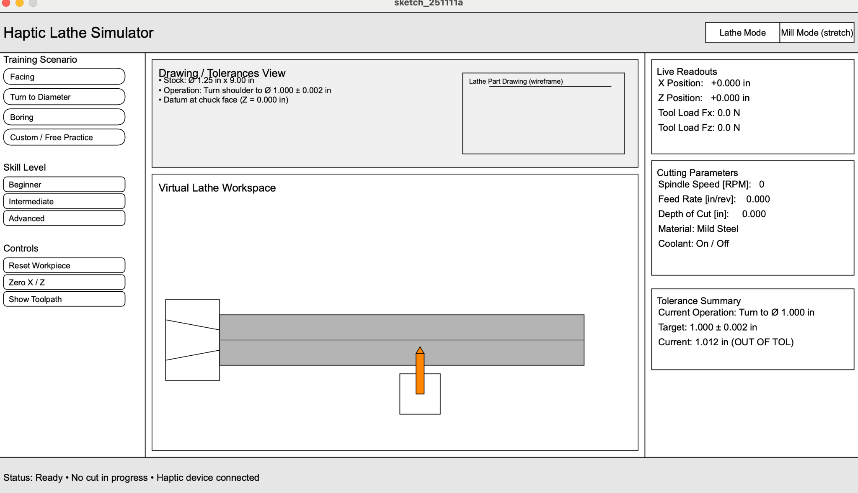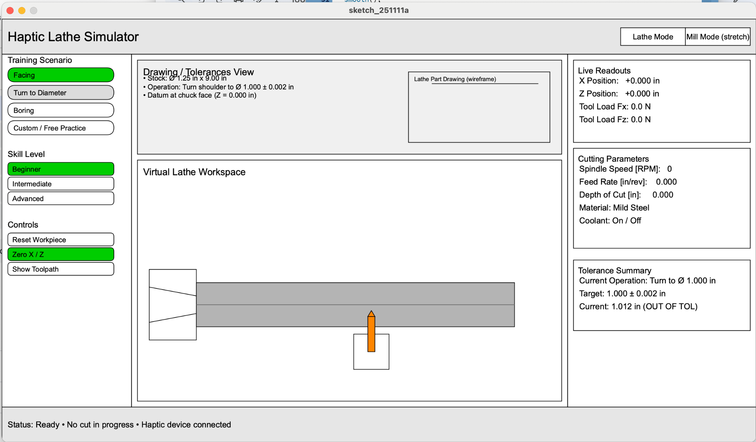

### 

#### Cutting + Haptic Code

The code sets up an initial point grid of stock

The program constantly checks if the tool tip is engaged

If engaged, user feels damping proportional to feedrate and stepover

Remove stock based on the profile of the insert

const int col = 100; //z

const int row = 30; //x

bool grid[col][row] = false; // stock grid

for (int z = 10; z < col; z++) {

for (int x = 10; x < row; x++) {

grid[z][x] = true;

}

}

b = 45;

k = 100;

fz = 0;

fx = 0;

if (grid[xh1][xh2]==true) { // if tool tip in stock

int minx(int z) {

for(int x = 0; x < ROW; x++) {

if(grid[z][x] == true) {

return x;

}

}

return -1;

}

fz = b * (dxh_filt1) + k * (xh2-x);

fx = b * (dxh_filt2) + k * (xh2-x);

for (int x = xh2, x >= xh2-4, x--){ // set stock to false

if (x==xh2){

int c = 0;

} else if (x==xh2-1) {

int c = 1;

} else if (x==xh2-3) {

int c = 2;

} else if (x==xh2-4) {

int c = 3;

} else {

break;

}

for (int z = xh1-c, x <= xh1, x++){

grid[z][x] = false;

}

}

} else {

fz = 0;

fx = 0;

}

### 

### Ordered Parts

| Item | Quantity | Price/Item | Total Cost |
| --- | --- | --- | --- |
| [Raspberry Pi Pico](https://www.digikey.com/en/products/detail/raspberry-pi/SC0915/13684020?gclsrc=aw.ds&gad_source=1&gad_campaignid=20243136172&gbraid=0AAAAADrbLlif_aM18D0WIsD3s6SQEYGU0&gclid=CjwKCAiAzrbIBhA3EiwAUBaUdRmsF5EcLQKw4tsK1Ak1hprX4-Jj5EuZ-PS-C71enuHa_nxpypXg8RoCeesQAvD_BwE) | 1 | 4 | 4 |
| [Shaft Coupler](https://www.amazon.com/Cionyce-Coupling-Support-Hardness-Connector/dp/B0B63PVPSX?crid=1LCIXSRGA1A0I&dib=eyJ2IjoiMSJ9.d5JalNhmgl0WD7_x48eWM3Q_GL2ywUs2iZWlGRmr2pequ5UjsiVA2SREbLMJaa3B_NLOwLgW3xE8a-PDc7rJMM1FoQHkbE4DeJaQAlc4tnjrBinxD8ta0NVVxeeTNoL4DVBG2JOVW0FZJdRrNxJ0FwPxEEdcxbX5mI63zDBaOK1OObdMiYLvFNIVUrbbd3K236QQt5Ifg5XMDfrMNjOLIN9RqjEwME3kZaTBRqOAvZk.3ePxQM_Y1rMQguzjVfG-PMu3lTedd_4RoYt66f9LVXk&dib_tag=se&keywords=shaft%2Bcoupler%2Bflange%2B6mm&qid=1762289196&sprefix=shaft%2Bcoupler%2Bflange%2B6mm%2Caps%2C160&sr=8-4&th=1) | 1 | 4.5 | 4.5 |
| [Motor](https://www.amazon.com/CQRobot-Ocean-6V-3W-20RPM-40-oz-12V-6W-40RPM-70/dp/B08ZK97WLY?crid=3GPVO4IQZOQ73&dib=eyJ2IjoiMSJ9.X-mc67OQp3IUtg3NrTTFXUf51vWBB0LRHjMpuT_8ZToCyetVkOCyNhEUgUKeaxqDgESI_TuFipkRzFrTjm4TR3HG4xFlaRQLSXryuCJdqWMkjwuchS02yYFO8zd8M5qXaUi3EFqqYwacPlGBUURWPOS88zwfdkK9EStQMWJCa0KDQH3am9hOfQpK5a024nUGbjlLyS8lNy_s4CgnL42RexuDSLBvNAD677tcRORpf5mk5Ed1JCml0XJxqNRAqB93aJW0A494c6NBcWxXXA4oSU9X8KLKrbZW6VRMgrAX9zQ.w90hR2OUHzSn192SNStcOd8QJC7v7S3hsdIOVr_CqSQ&dib_tag=se&keywords=dc%2Bmotors%2Bwith%2Bencoders&qid=1762133625&sprefix=dc%2Bmotors%2B%2Caps%2C207&sr=8-10&th=1) (70:1 model) | 1 | 34 | 34 |
| [Motor driver](https://www.amazon.com/DROK-Controller-Regulator-Industrial-Optocoupler/dp/B06XGD5SCB?crid=32ZZTMZNNCP7C&dib=eyJ2IjoiMSJ9.DnwLNP6NABo3SloZUw5Ng7vUy8kOugTvj0ZT5ejBju7Kdpwv3ZYCrOgICn35EqmCkeevj9hVNd9g28kRdREnpaA09iK9L1ZrlK3y8P53IMMPh_X1epPiHOc5Bz09_uxK12cYEFwQQ_syBnaOOS9O_5sNzgnIfiAX9JK9NqBL1360eLmqYND9JJOzkG6pkNn1uK2IE9Pm58aKCcLgxzSt_2ie-TkcwN1SAuk7VpMe2wc.dTtsqbvcLVLJSIKyLyw7JQOpeN-6SmAdHWfyyq6FrUc&dib_tag=se&keywords=5%2Bamp%2Bdc%2Bmotor%2Bdriver&qid=1762291848&sprefix=5%2Bamp%2Bdc%2Bmotor%2Bdrive%2Caps%2C142&sr=8-2&th=1) | 1 | 15.7 | 15.7 |

Total: $58.20

### CAD

### 

#### GUI code:

// Haptic Lathe Simulator GUI

// Stock dimensions driven by inches -> pixels

int W = 1280;

int H = 720;

int headerH = 60;

int footerH = 60;

int leftPanelW = 220;

int rightPanelW = 320;

int padding = 10;

// Colors (will be set in setup)

int bgColor;

int panelStroke;

int panelFill;

int headerFill;

int footerFill;

int accentFill;

// ----- Stock dimensions (change these in inches) -----

float stockLengthIn = 9.0; // length of stock in inches

float stockDiameterIn = 1.25; // diameter of stock in inches

float pxPerIn = 60.0; // scale factor: pixels per inch

// ----- Button state booleans -----

// Training scenario

boolean facingSelected = false;

boolean turnDiaSelected = false;

boolean boringSelected = false;

boolean customSelected = false;

// Skill level

boolean beginnerSelected = false;

boolean intermediateSelected = false;

boolean advancedSelected = false;

// Controls

boolean resetSelected = false;

boolean zeroSelected = false;

boolean pathSelected = false;

// ----------------------------------------------------

// Processing 4:

// ----------------------------------------------------

void setup() {

size(1280, 720);

smooth();

textAlign(LEFT, CENTER);

textFont(createFont("Arial", 14));

// Define colors now that the window exists

bgColor = color(245);

panelStroke = color(0);

panelFill = color(255);

headerFill = color(230);

footerFill = color(230);

accentFill = color(240);

}

void draw() {

background(bgColor);

drawHeader();

drawFooter();

drawLeftPanel();

drawRightPanel();

drawMainView();

}

// ----------------------------------------------------

// HEADER

// ----------------------------------------------------

void drawHeader() {

fill(headerFill);

stroke(panelStroke);

rect(0, 0, W, headerH);

fill(0);

textSize(22);

text("Haptic Lathe Simulator", padding, headerH / 2);

// Mode toggle visual (static for now)

float toggleW = 220;

float toggleH = 30;

float toggleX = W - toggleW - padding;

float toggleY = headerH / 2 - toggleH / 2;

// Lathe mode

fill(255);

stroke(0);

rect(toggleX, toggleY, toggleW / 2, toggleH);

fill(0);

textSize(13);

textAlign(CENTER, CENTER);

text("Lathe Mode", toggleX + toggleW / 4, toggleY + toggleH / 2);

// Mill mode (stretch goal)

fill(255);

stroke(0);

rect(toggleX + toggleW / 2, toggleY, toggleW / 2, toggleH);

fill(0);

text("Mill Mode (stretch)", toggleX + 3 * toggleW / 4, toggleY + toggleH / 2);

textAlign(LEFT, CENTER);

}

// ----------------------------------------------------

// FOOTER

// ----------------------------------------------------

void drawFooter() {

float y = H - footerH;

fill(footerFill);

stroke(panelStroke);

rect(0, y, W, footerH);

fill(0);

textSize(14);

text("Status: Ready • No cut in progress • Haptic device connected",

padding, y + footerH / 2);

}

// ----------------------------------------------------

// LEFT PANEL (buttons with hover + selected states)

// ----------------------------------------------------

void drawLeftPanel() {

float x = 0;

float y = headerH;

float h = H - headerH - footerH;

fill(panelFill);

stroke(panelStroke);

rect(x, y, leftPanelW, h);

float innerX = x + padding;

float innerY = y + padding;

// ----- Training Scenario -----

drawSubPanelTitle(innerX, innerY, "Training Scenario");

innerY += 25;

drawPillButton(innerX, innerY, "Facing", facingSelected);

innerY += 30;

drawPillButton(innerX, innerY, "Turn to Diameter", turnDiaSelected);

innerY += 30;

drawPillButton(innerX, innerY, "Boring", boringSelected);

innerY += 30;

drawPillButton(innerX, innerY, "Custom / Free Practice", customSelected);

// ----- Skill Level -----

innerY += 45;

drawSubPanelTitle(innerX, innerY, "Skill Level");

innerY += 25;

drawOutlinedButton(innerX, innerY, "Beginner", beginnerSelected);

innerY += 25;

drawOutlinedButton(innerX, innerY, "Intermediate", intermediateSelected);

innerY += 25;

drawOutlinedButton(innerX, innerY, "Advanced", advancedSelected);

// ----- Controls -----

innerY += 45;

drawSubPanelTitle(innerX, innerY, "Controls");

innerY += 25;

drawOutlinedButton(innerX, innerY, "Reset Workpiece", resetSelected);

innerY += 25;

drawOutlinedButton(innerX, innerY, "Zero X / Z", zeroSelected);

innerY += 25;

drawOutlinedButton(innerX, innerY, "Show Toolpath", pathSelected);

}

// ----------------------------------------------------

// RIGHT PANEL (static info)

// ----------------------------------------------------

void drawRightPanel() {

float x = W - rightPanelW;

float y = headerH;

float h = H - headerH - footerH;

fill(panelFill);

stroke(panelStroke);

rect(x, y, rightPanelW, h);

float innerX = x + padding;

float innerY = y + padding;

float sectionW = rightPanelW - 2 * padding;

// Live readouts

drawSubPanelBox(innerX, innerY, sectionW, 140, "Live Readouts");

float lineY = innerY + 35;

float lineH = 22;

fill(0);

textSize(14);

text("X Position: +0.000 in", innerX + 10, lineY); lineY += lineH;

text("Z Position: +0.000 in", innerX + 10, lineY); lineY += lineH;

text("Tool Load Fx: 0.0 N", innerX + 10, lineY); lineY += lineH;

text("Tool Load Fz: 0.0 N", innerX + 10, lineY); lineY += lineH;

innerY += 150;

// Cutting parameters

drawSubPanelBox(innerX, innerY, sectionW, 170, "Cutting Parameters");

lineY = innerY + 35;

text("Spindle Speed [RPM]: 0", innerX + 10, lineY); lineY += lineH;

text("Feed Rate [in/rev]: 0.000", innerX + 10, lineY); lineY += lineH;

text("Depth of Cut [in]: 0.000", innerX + 10, lineY); lineY += lineH;

text("Material: Mild Steel", innerX + 10, lineY); lineY += lineH;

text("Coolant: On / Off", innerX + 10, lineY);

innerY += 190;

// Tolerance summary

drawSubPanelBox(innerX, innerY, sectionW, 120, "Tolerance Summary");

lineY = innerY + 35;

text("Current Operation: Turn to Ø 1.000 in", innerX + 10, lineY); lineY += lineH;

text("Target: 1.000 ± 0.002 in", innerX + 10, lineY); lineY += lineH;

text("Current: 1.012 in (OUT OF TOL)", innerX + 10, lineY);

}

// ----------------------------------------------------

// MAIN VIEW (virtual lathe + inch-based stock)

// ----------------------------------------------------

void drawMainView() {

float x = leftPanelW;

float y = headerH;

float w = W - leftPanelW - rightPanelW;

float h = H - headerH - footerH;

fill(panelFill);

stroke(panelStroke);

rect(x, y, w, h);

float innerX = x + padding;

float innerY = y + padding;

float innerW = w - 2 * padding;

float innerH = h - 2 * padding;

// --- Drawing section (top) ---

float drawingH = 160;

fill(accentFill);

rect(innerX, innerY, innerW, drawingH);

fill(0);

textSize(16);

text("Drawing / Tolerances View", innerX + 10, innerY + 20);

textSize(12);

text("• Stock: Ø " + nf(stockDiameterIn, 1, 2) + " in x " +

nf(stockLengthIn, 1, 2) + " in\n" +

"• Operation: Turn shoulder to Ø 1.000 ± 0.002 in\n" +

"• Datum at chuck face (Z = 0.000 in)",

innerX + 10, innerY + 45);

// Drawing thumbnail

float printX = innerX + innerW - 260;

float printY = innerY + 20;

float printW = 240;

float printH = drawingH - 40;

noFill();

stroke(0);

rect(printX, printY, printW, printH);

line(printX + 40, printY + 20, printX + printW - 20, printY + 20);

textSize(10);

text("Lathe Part Drawing (wireframe)", printX + 10, printY + 12);

// --- Workspace (bottom) ---

float workspaceY = innerY + drawingH + padding;

float workspaceH = innerH - drawingH - padding;

fill(255);

rect(innerX, workspaceY, innerW, workspaceH);

fill(0);

textSize(16);

text("Virtual Lathe Workspace", innerX + 10, workspaceY + 20);

// Lathe geometry

float centerY = workspaceY + workspaceH * 0.6;

float chuckX = innerX + 100;

float chuckW = 80;

float chuckH = 120;

// Convert inches to pixels for stock

float stockLenPx = stockLengthIn * pxPerIn;

float stockHPx = stockDiameterIn * pxPerIn;

// Keep stock from overflowing the workspace too crazily

stockLenPx = min(stockLenPx, innerW * 0.75);

stockHPx = min(stockHPx, workspaceH * 0.6);

// Chuck

noFill();

stroke(0);

rect(chuckX - chuckW, centerY - chuckH / 2, chuckW, chuckH);

line(chuckX - chuckW, centerY - 30, chuckX, centerY - 15);

line(chuckX - chuckW, centerY + 30, chuckX, centerY + 15);

// Stock (filled rectangle, inch-scaled)

fill(180); // light gray metal

stroke(0);

rect(chuckX, centerY - stockHPx / 2, stockLenPx, stockHPx);

// centerline

stroke(100);

line(chuckX, centerY, chuckX + stockLenPx, centerY);

// ---------------- TOOL POST AND CUTTING TOOL (below stock) ----------------

stroke(0);

fill(255);

float toolX = chuckX + stockLenPx * 0.55; // roughly mid-stock

float toolY = centerY + 80; // below stock centerline

// Tool post block (support)

rect(toolX - 30, toolY - 30, 60, 60);

// --- Cutting tool geometry ---

// Vertical shank positioned below the stock

float toolShankW = 12;

float toolShankH = 60;

float toolShankX = toolX - toolShankW/2;

float toolShankY = centerY + 20; // start just below the stock

fill(255, 140, 0); // gray metal shank

stroke(0);

rect(toolShankX, toolShankY, toolShankW, toolShankH);

// Orange pointed tip facing upward toward stock

float tipW = 12; // width of the tip triangle

float tipH = 10; // height of the tip triangle

float tipBaseX = toolShankX;

float tipBaseY = toolShankY; // base of the triangle at top of shank

fill(255, 140, 0); // orange tip

stroke(0);

triangle(

tipBaseX, tipBaseY, // left corner of triangle base

tipBaseX + toolShankW, tipBaseY, // right corner of triangle base

tipBaseX + toolShankW/2, tipBaseY - tipH // tip point above center of base

);

}

// ----------------------------------------------------

// BUTTON DRAW HELPERS (hover + selected color logic)

// ----------------------------------------------------

void drawSubPanelTitle(float x, float y, String title) {

fill(0);

textSize(14);

text(title, x, y);

}

void drawPillButton(float x, float centerY, String label, boolean selected) {

float w = 180;

float h = 24;

float y = centerY - h / 2;

boolean hover = overRect(x, y, w, h);

if (selected) {

fill(0, 200, 0); // green when selected

} else if (hover) {

fill(220); // light gray when hovering

} else {

fill(255); // white default

}

stroke(0);

rect(x, y, w, h, 12);

fill(0);

textSize(12);

text(label, x + 10, centerY);

}

void drawOutlinedButton(float x, float centerY, String label, boolean selected) {

float w = 180;

float h = 22;

float y = centerY - h / 2;

boolean hover = overRect(x, y, w, h);

if (selected) {

fill(0, 200, 0); // green when selected

} else if (hover) {

fill(220); // light gray on hover

} else {

noFill();

}

stroke(0);

rect(x, y, w, h, 6);

fill(0);

textSize(12);

text(label, x + 8, centerY);

}

void drawSubPanelBox(float x, float y, float w, float h, String title) {

fill(255);

stroke(0);

rect(x, y, w, h);

fill(0);

textSize(14);

text(title, x + 8, y + 18);

}

// Simple line with arrowhead

void arrow(float x1, float y1, float x2, float y2) {

line(x1, y1, x2, y2);

float angle = atan2(y2 - y1, x2 - x1);

float len = 20;

float a1 = angle + radians(150);

float a2 = angle - radians(150);

line(x2, y2, x2 - len * cos(a1), x2 - len * sin(a1));

line(x2, y2, x2 - len * cos(a2), x2 - len * sin(a2));

}

// Hit-test helper

boolean overRect(float x, float y, float w, float h) {

return (mouseX >= x && mouseX <= x + w &&

mouseY >= y && mouseY <= y + h);

}

// ----------------------------------------------------

// MOUSE INTERACTION: toggle selected state on click

// ----------------------------------------------------

void mousePressed() {

float x = 0;

float y = headerH;

float innerX = x + padding;

float innerY = y + padding;

// ---- Positions mirror drawLeftPanel() logic ----

// Training Scenario

innerY += 25; // Facing center Y

if (overRect(innerX, innerY - 12, 180, 24)) facingSelected = !facingSelected;

innerY += 30; // Turn to Diameter

if (overRect(innerX, innerY - 12, 180, 24)) turnDiaSelected = !turnDiaSelected;

innerY += 30; // Boring

if (overRect(innerX, innerY - 12, 180, 24)) boringSelected = !boringSelected;

innerY += 30; // Custom

if (overRect(innerX, innerY - 12, 180, 24)) customSelected = !customSelected;

// Skill Level

innerY += 45; // title

innerY += 25; // Beginner

if (overRect(innerX, innerY - 11, 180, 22)) beginnerSelected = !beginnerSelected;

innerY += 25; // Intermediate

if (overRect(innerX, innerY - 11, 180, 22)) intermediateSelected = !intermediateSelected;

innerY += 25; // Advanced

if (overRect(innerX, innerY - 11, 180, 22)) advancedSelected = !advancedSelected;

// Controls

innerY += 45; // title

innerY += 25; // Reset Workpiece

if (overRect(innerX, innerY - 11, 180, 22)) resetSelected = !resetSelected;

innerY += 25; // Zero X/Z

if (overRect(innerX, innerY - 11, 180, 22)) zeroSelected = !zeroSelected;

innerY += 25; // Show Toolpath

if (overRect(innerX, innerY - 11, 180, 22)) pathSelected = !pathSelected;

}

Checkpoint 3

# Haptic Lathe Simulator

### Description

We are building a two‑DOF haptic training device that mimics the hand‑feel of operating a manual lathe. The user turns two perpendicular, directly‑driven handwheels (X cross‑slide and Z carriage). A virtual lathe environment renders stock, tool, drawings/tolerances, and live readouts of X/Z positions. The device computes and reflects realistic cutting forces/torques based on spindle speed, feed, and depth of cut—allowing trainees to practice common machining operations (e.g., facing, turning to diameter, boring) in a low‑risk setting while building correct muscle memory. The architecture extends naturally to a milling mode (stretch goal).

### Checkpoints & Deliverables

We are currently on track with our project goals. There is a chance that our parts may come in later than expected. That being said there is plenty we can be working on without our motor and pico. We can test our code on the hapkit.

**Checkpoint 1 — System requirements & concept freeze (Nov 4)**

* Description of Device
* Literature review
* Establish all system requirements
* Initial sketch of the haptic device which include mechanism layout, motor mounts, handles, UI
* Force/Torque Calculations
* Motor selection
* Additional Component Selection
* Electronics selection
* BOM

**Checkpoint 2 — Detailed Mechanical design, parts ordered, and Initial UI (Nov 11)**

* UI wireframe; simple stock/tool visualization running
* CAD for Motor Mount and handles
* Ordered Materials

**Checkpoint 3 — Integration & basic haptics (Nov 18)**

* ~~Manufacture device~~
* UI linked to motors, live position handling
* 1 task (turning or boring) with scoring
* Single‑axis torque rendering demo (constant “cut” depth)
* ~~Add functionality to GUI buttons~~

**Checkpoint 4 — MVP demo (Nov 25)**

* Two tasks (turning & boring) fully guided with scoring
* Two-axis torque rendering
* Design Pilot study

**Checkpoint 5 — Refinement and User Pilot Study (Dec 2)**

* Refinement of system
* Complete Pilot Study

### GUI Progress

Added functionality to buttons

* Training Scenario buttons change the Drawing/Tolerances View, and the Virtual Lathe Workspace
* The Skill Level buttons change the tolerances for each training Scenario
* The X position and Z Positions have been setup to update in the live readout window
* The Zero X and Zero Y buttons cause the live readout to zero, but do not move the virtual tool to 0,0
* You can adjust cutting parameters, such as RPM & FeedRate.
  + When you change RPM there is an animation of the stock spinning.

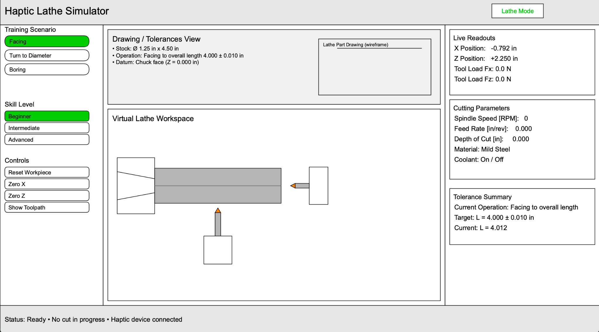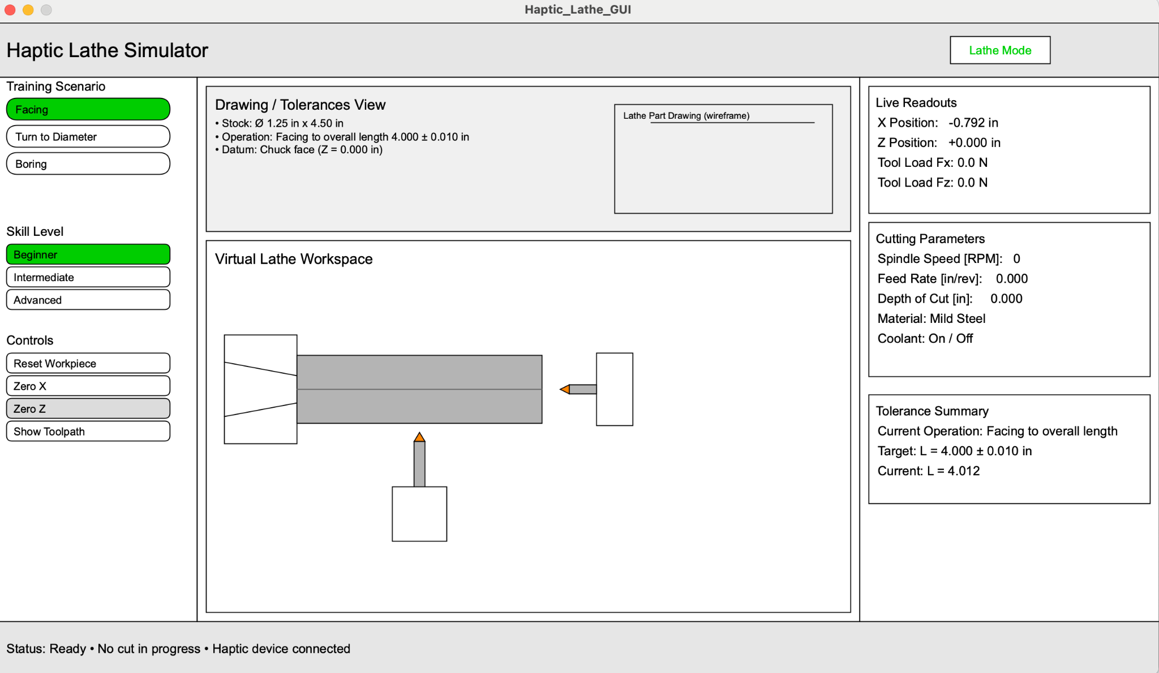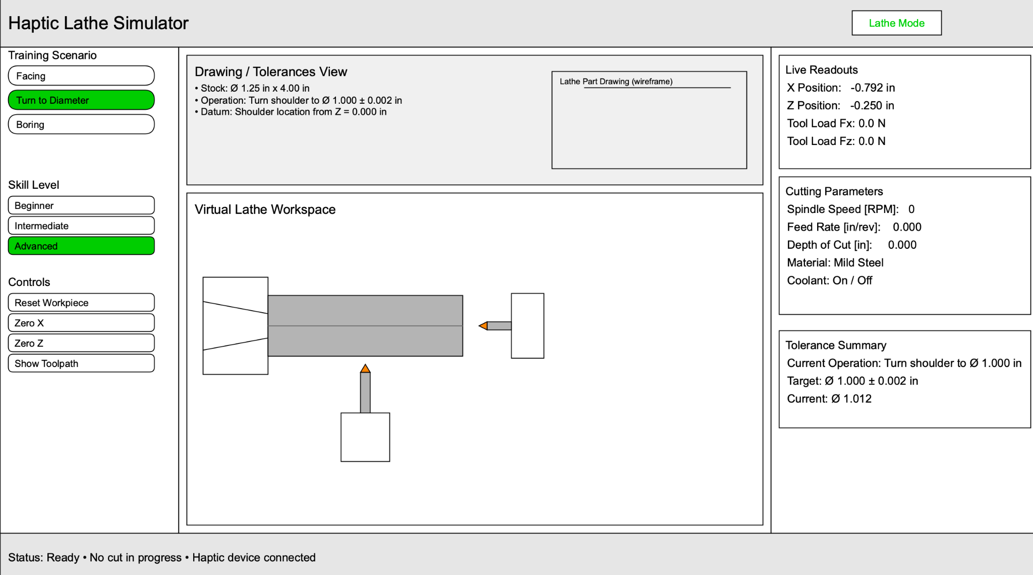

### Hardware progress:

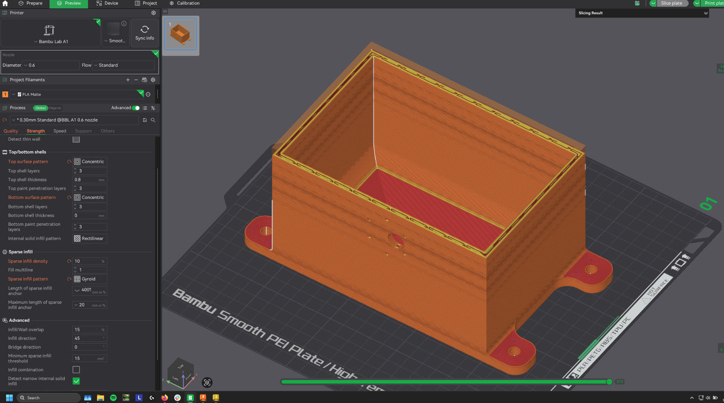

Starting 3d print and assembly

Checkpoint 4

# Haptic Lathe Simulator

### Description

We are building a two‑DOF haptic training device that mimics the hand‑feel of operating a manual lathe. The user turns two perpendicular, directly‑driven handwheels (X cross‑slide and Z carriage). A virtual lathe environment renders stock, tool, drawings/tolerances, and live readouts of X/Z positions. The device computes and reflects realistic cutting forces/torques based on spindle speed, feed, and depth of cut—allowing trainees to practice common machining operations (e.g., facing, turning to diameter, boring) in a low‑risk setting while building correct muscle memory. The architecture extends naturally to a milling mode (stretch goal).

### Checkpoints & Deliverables

We are currently on track with our project goals. There is a chance that our parts may come in later than expected. That being said there is plenty we can be working on without our motor and pico. We can test our code on the hapkit.

**Checkpoint 1 — System requirements & concept freeze (Nov 4)**

* Description of Device
* Literature review
* Establish all system requirements
* Initial sketch of the haptic device which include mechanism layout, motor mounts, handles, UI
* Force/Torque Calculations
* Motor selection
* Additional Component Selection
* Electronics selection
* BOM

**Checkpoint 2 — Detailed Mechanical design, parts ordered, and Initial UI (Nov 11)**

* UI wireframe; simple stock/tool visualization running
* CAD for Motor Mount and handles
* Ordered Materials

**Checkpoint 3 — Integration & basic haptics (Nov 18)**

* ~~Manufacture device~~
* ~~UI linked to motors, live position handling~~
* 1 task (turning or boring) with scoring
* Single‑axis torque rendering demo (constant “cut” depth)
* ~~Add functionality to GUI buttons~~

**Checkpoint 4 — MVP demo (Nov 25)**

* ~~Finalize CAD~~
* ~~Position tracking in GUI~~

**Checkpoint 5 — Refinement and User Pilot Study (Dec 2)**

* Two tasks (turning & boring) fully guided with scoring
* Two-axis torque rendering
* Pilot study

### 

### Software Progress

* Tool moves with motor
  + GUI moves with motor

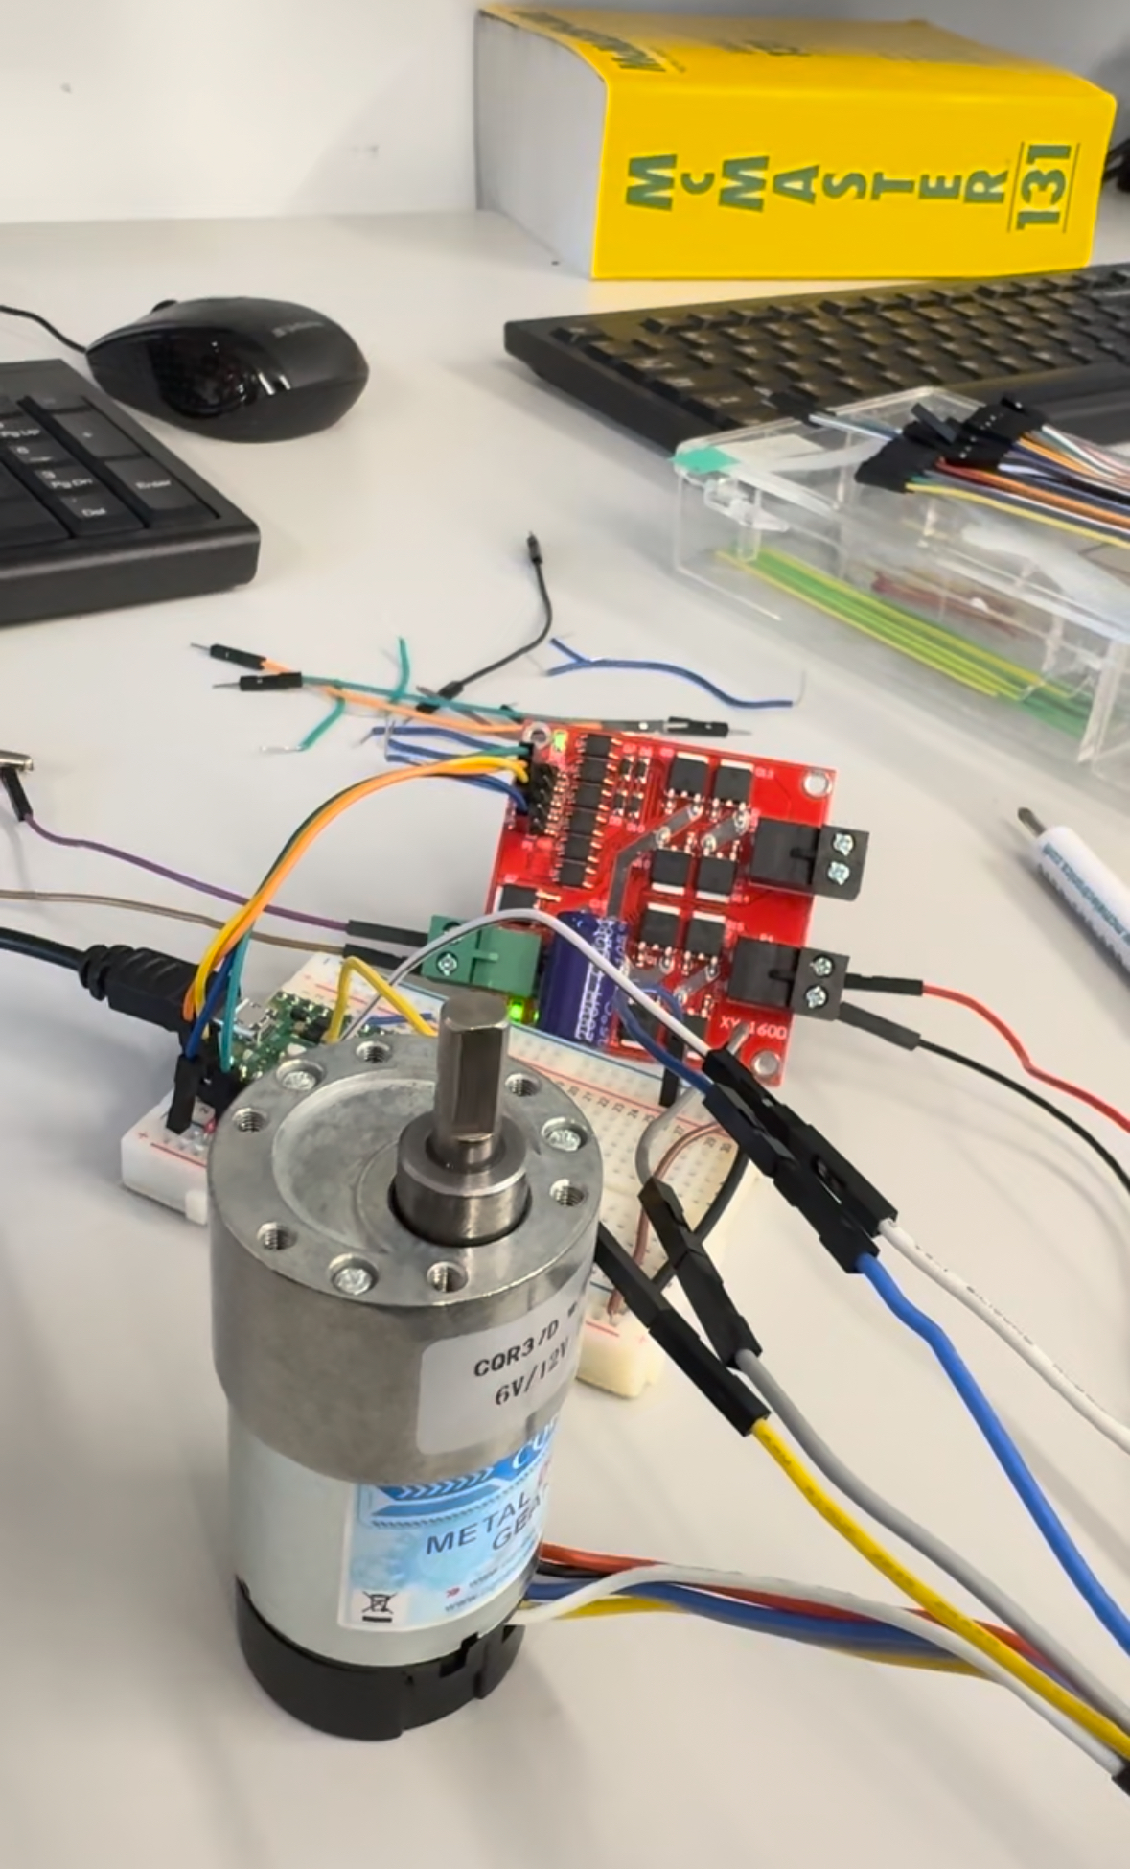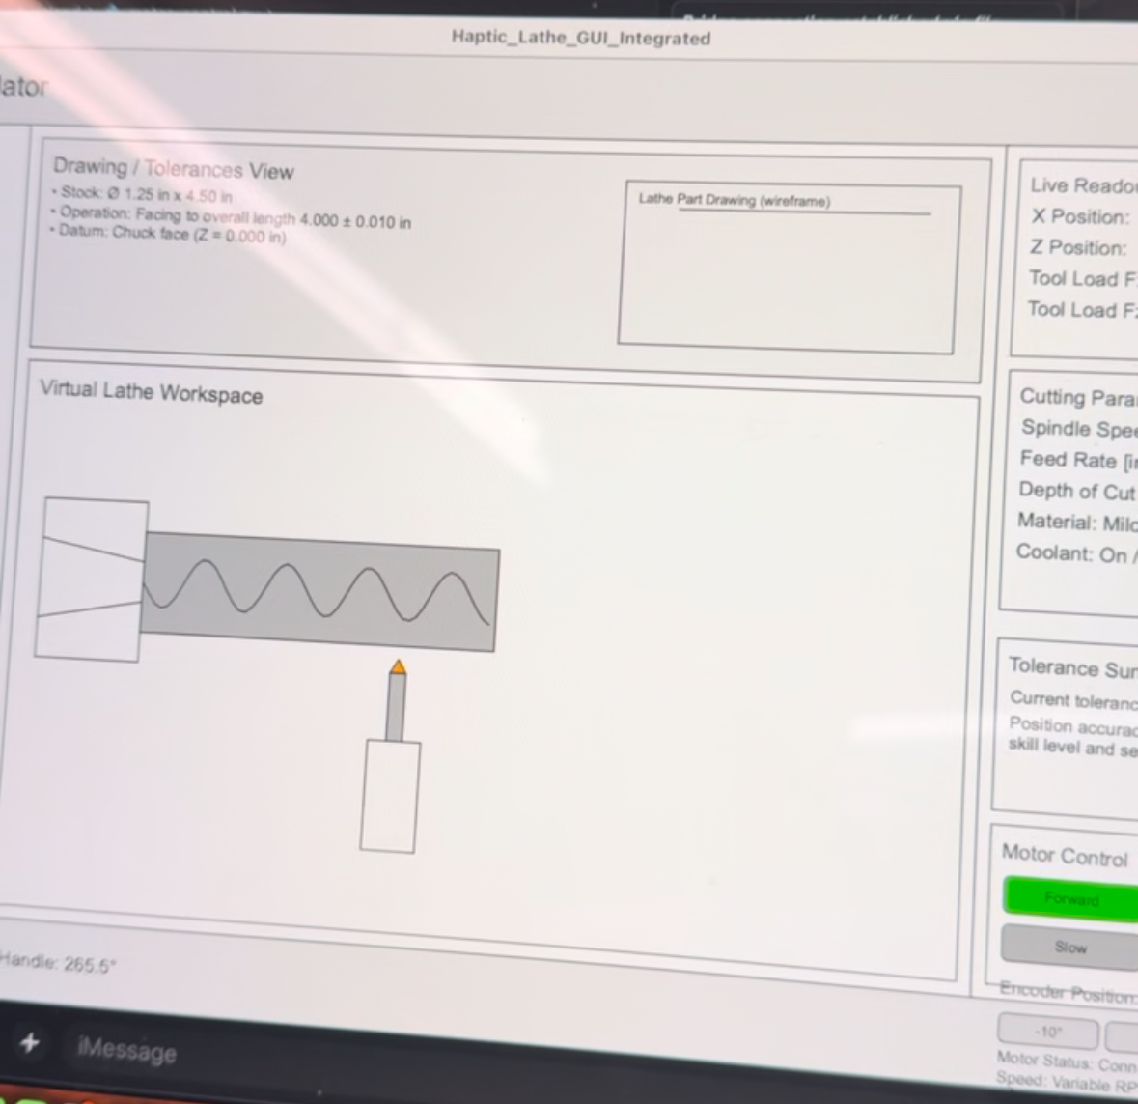



### Hardware progress:

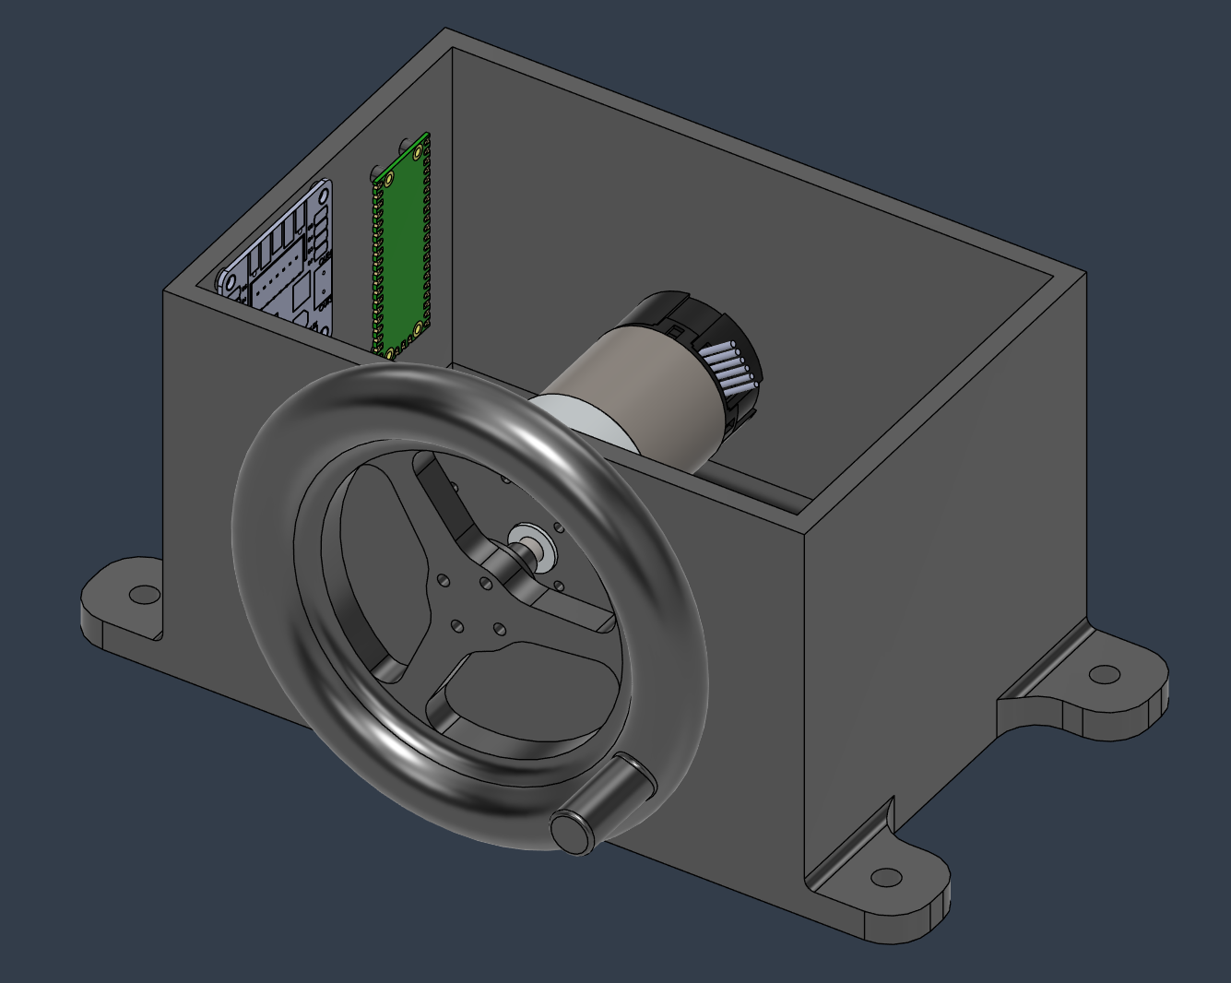

Finalized CAD with a redesign

-printable handle wheel

-proper board mount with print in place standoff and self tapping threads

Printing over break

Checkpoint 5

# Haptic Lathe Simulator

### Description

We are building a two‑DOF haptic training device that mimics the hand‑feel of operating a manual lathe. The user turns two perpendicular, directly‑driven handwheels (X cross‑slide and Z carriage). A virtual lathe environment renders stock, tool, drawings/tolerances, and live readouts of X/Z positions. The device computes and reflects realistic cutting forces/torques based on spindle speed, feed, and depth of cut—allowing trainees to practice common machining operations (e.g., facing, turning to diameter, boring) in a low‑risk setting while building correct muscle memory. The architecture extends naturally to a milling mode (stretch goal).

### Progress Description

We are currently on track with our project goals.

* Printed Parts and Manufactured device
* GUI and microcontroller working together
  + GUI refinement
  + Working on animating stock
* Adjusting and tuning haptic feedback

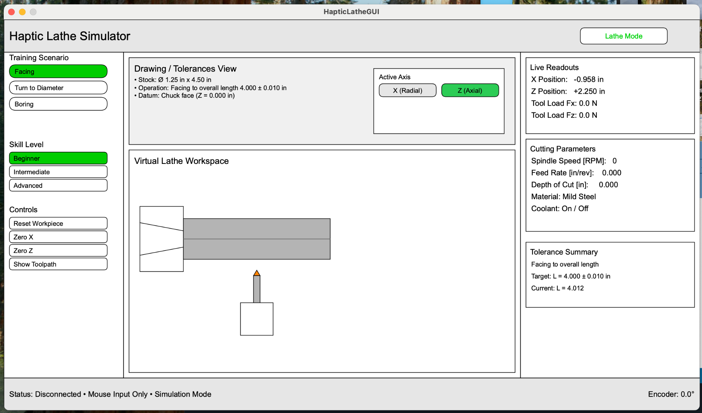

### 



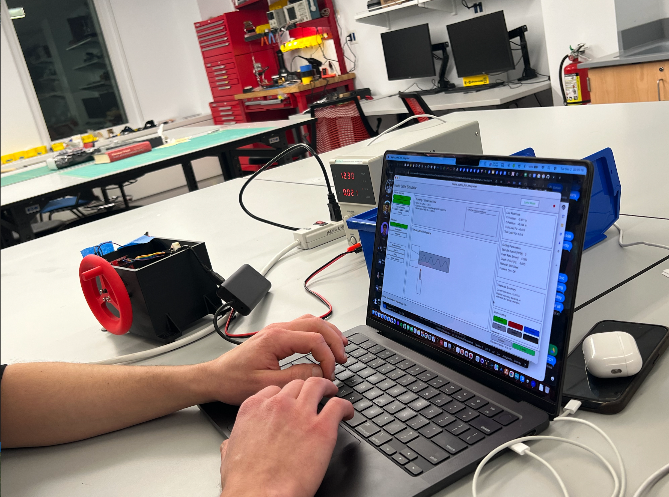

### Hardware progress:

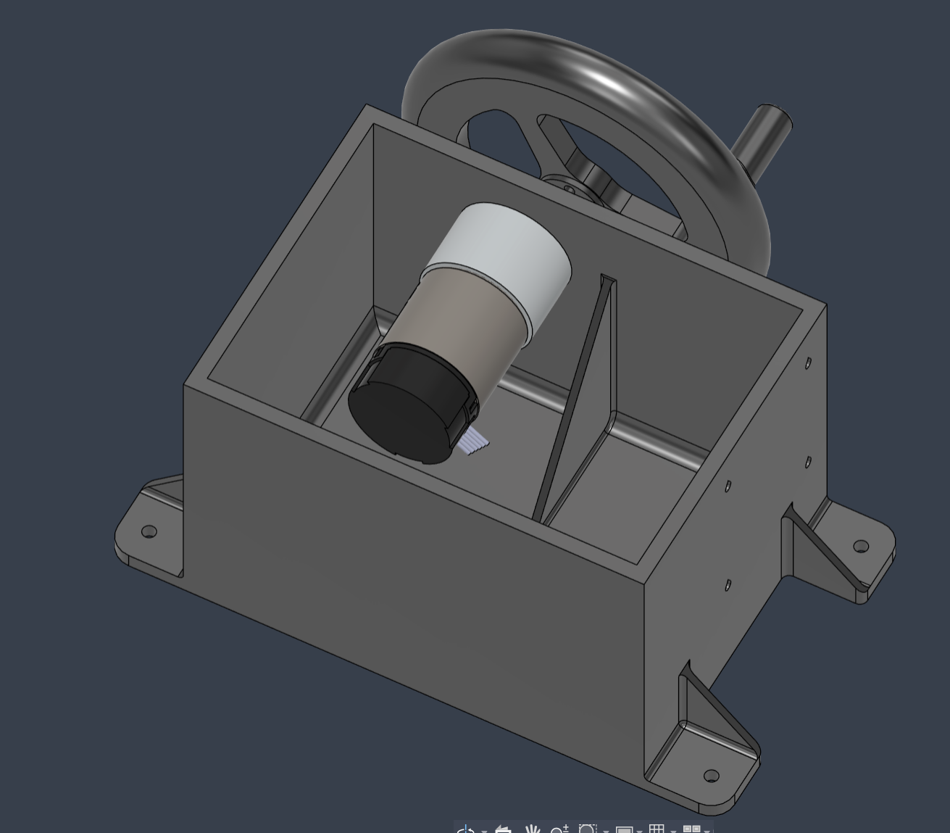

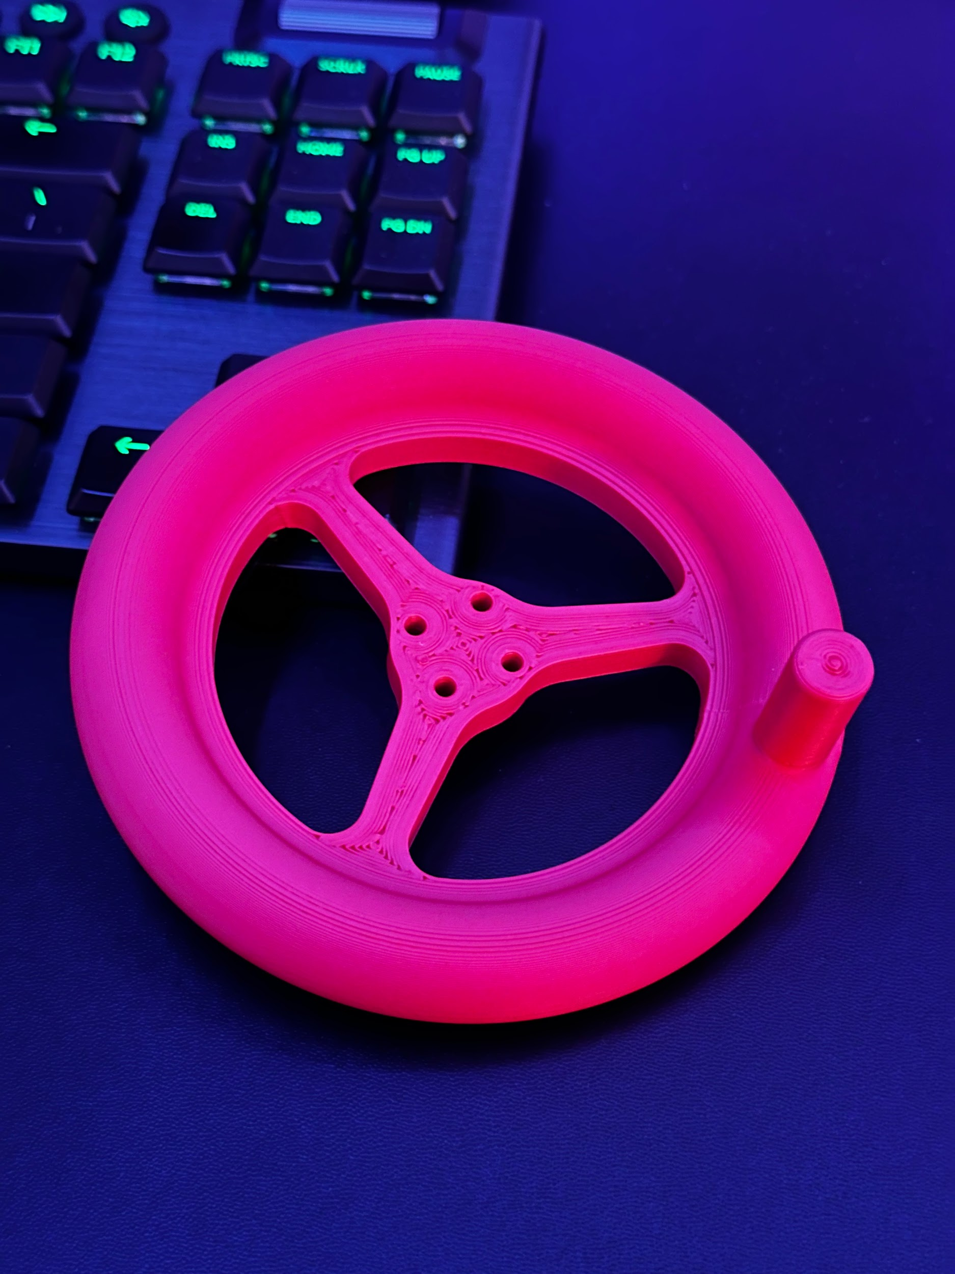

Housing revisited, printed, and assembled

Poster

Haptic Lathe Simulator

By Caleb Farrelly, Daria Kot, and Richard Zheng

## Description

We are building a haptic training device that mimics the tactile experience of operating a manual lathe, enabling students and beginners to practice machining fundamentals. The system consists of a hand wheel attached to a geared DC motor, which is connected to a virtual lathe environment. The user can choose in the virtual environment whether to control the X-axis or Z axis.

The virtual lathe environment renders stock, tool, drawings/tolerances, and live readouts of X/Z positions. The device provides haptic feedback based on:

* Stock geometry
* Tool engagement
* Spindle Speed
* Feed rate

This allows users to feel phenomena such as:

* Increasing load during deeper cuts
* Sudden force changes when the tool enters/exits the material
* Tool chatter or instability cues

The user is able to feel haptic feedback in the form of virtual walls and vibrations.

Vibration frequency is a function of spindle speed, and amplitude is scaled with the rendered curing force.

The force a user feels when making a cut is proportional to the force a lathe's feed mechanism experiences, given by the equation: $FeedForce(F_{f})=K_{c}*f*a_{p}$

* Specific cutting force $K_{c}$ of the work
* feed per revolution $f$
* Depth of cut $a_{p}$

This equation calculates the tangential feed force, which is the force required to push the cutting tool along the workpiece.

## **Why This Matters**

Traditional lathe training requires physical machines, supervision, and carries risk. Our device offers:

* **Low-risk skill acquisition** before touching real equipment
* **Muscle-memory development** for feed control and cutting behavior
* **Repeatable exercises** without material waste
* **Accessible training** for students with limited shop experience

By integrating real-time force feedback with intuitive virtual visualization, this project bridges simulation and hands-on machining.

## Directions

* Select the axis of motion (Z or X)
* Rotate the handle in either +/- direction to move the tool
* Cutting occurs when the tool encounters the work
* Heavier cutting results in a rougher finish and lower accuracy
* Smaller cuts produce a smoother surface finish and higher accuracy at the cost of machining time

Final Report

Haptic Lathe Simulator

MAE 6800 Design and Control of Haptic Systems

Fall 2025

Caleb Farrelly, Daria Kot, and Richard Zheng

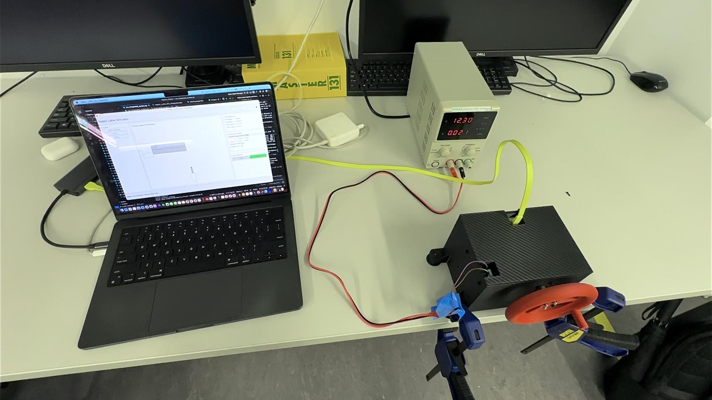

Table of Contents

Daria intro

Caleb Methods future work

Richard Background results acknowledgements

• Introduction: Explain the motivation for your project in terms of the educational objectives and why your haptic device is an appropriate approach.

• Background: Explain the relevant prior work in the field of haptics and provide references. These will likely be different from the references in your project proposal. Make sure to do a thorough literature search on relevant haptic devices/application.

• Methods: Provide a detailed description of your project, such that another student from the class could generally re-create your project/experiment from the report if necessary. (You don’t need to document every screw, but the design should be clear.) Add images and videos as needed to support the description. You can refer to downloadable drawings and code in the “Files” section (later). You should divide this section into subsections, which can vary depending on your particular project.

• Results: Describe the results, which may include qualitative responses from users at the open house.

• Future Work: Describe how your system could be tested (e.g., through experiments if you have not already done so), how it can be improved, and how it might be applied.

• Acknowledgments: Here you can list any individuals or groups who helped you with your project. This is optional, so delete this section if you aren’t using it.

• Files: Code and drawings should be linked here. You should be able to upload these using the

Attach command. If you aren't willing to share these data on a public site, please discuss with the

instructor. Also, in this section include a link to a file with a list of major components and their

approximate costs.

• References: List the referenced literature, websites, etc. here.